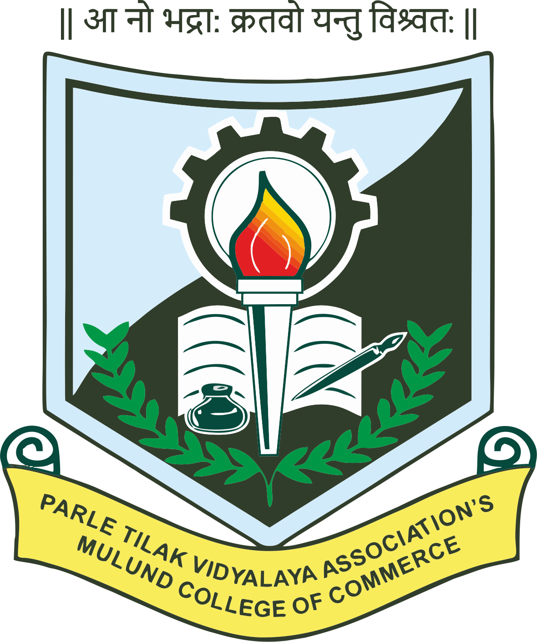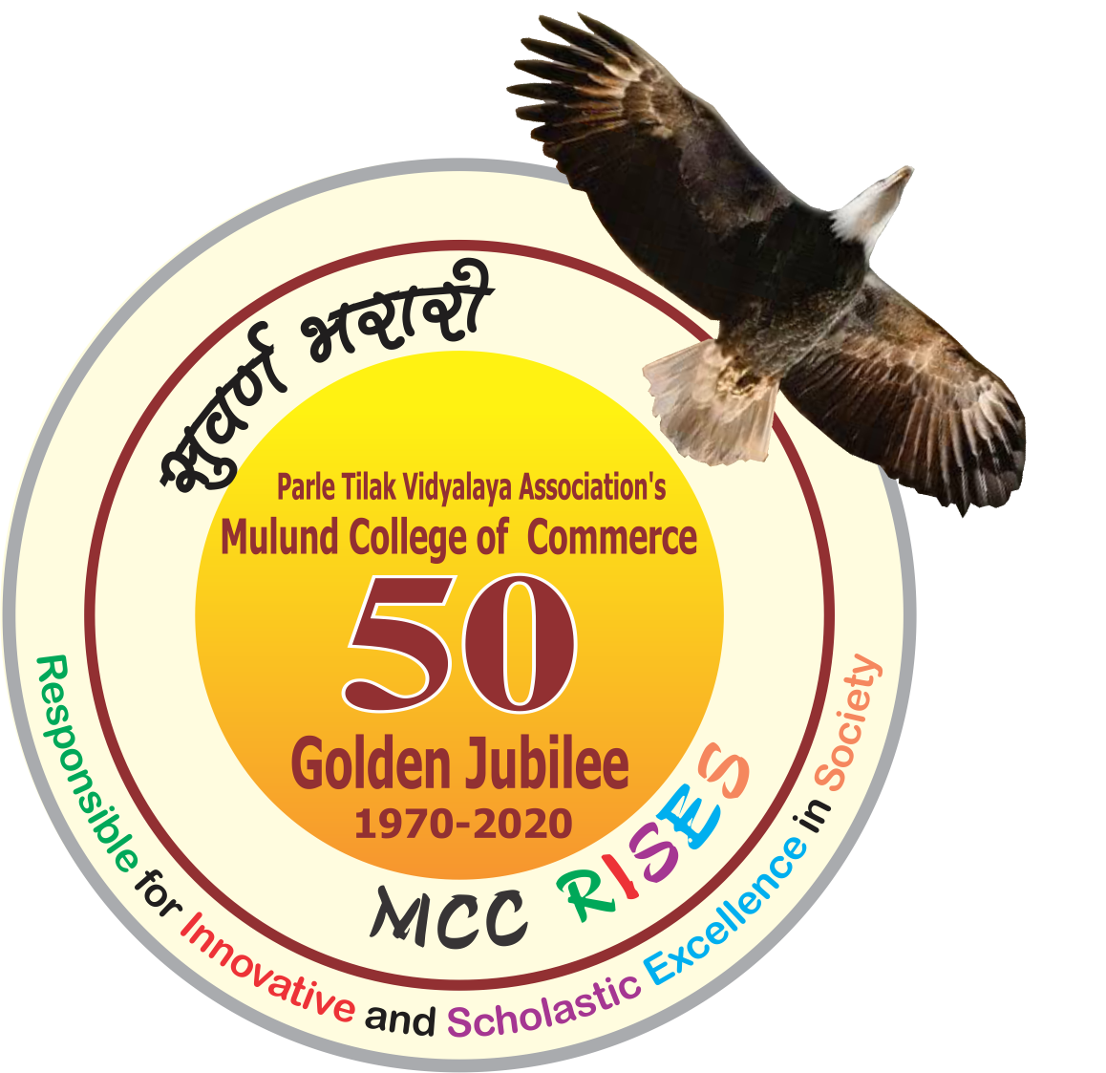

CyProbe

A National Conference on Advanced Research in Computer Science and Information Technology

Organised By

Internal Quality Assurance Cell
Department of Computer Science

Department Information Technology

Parle Tilak Vidyalaya Association's

Mulund College of Commerce

on

18th January 2020

Publication Partner
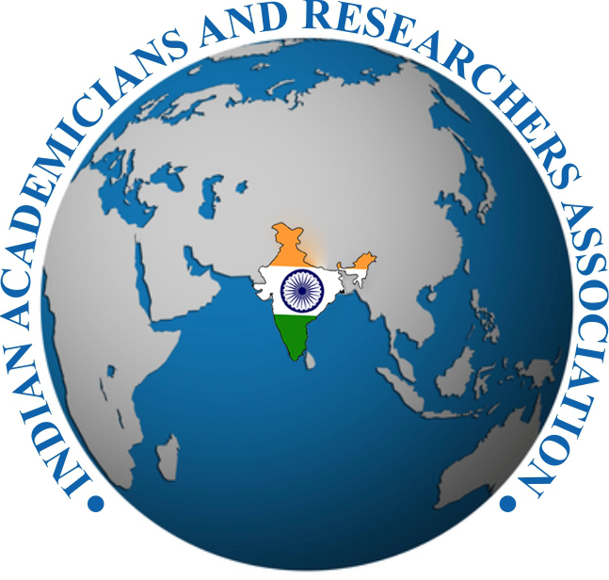
Indian Academicians and Researcher’s Association

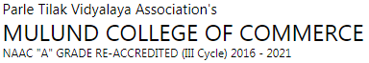

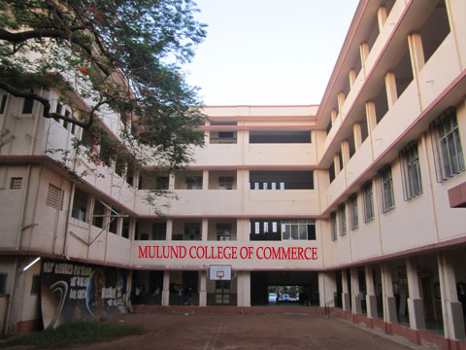

Guest Editors of Special Issue
Dr. Sonali Pednekar
Principal
PTVA’s Mulund College of Commerce, Mumbai

Dr. K. G. Rajan
Vice Principal
PTVA's Mulund College of Commerce, Mumbai

Dr. Hiren Dand
Head
Department of Information Technology
PTVA’s Mulund College of Commerce, Mumbai

About the Management
Parle Tilak Vidyalaya Association
A learned scholar, a great mathematician, philosopher, teacher and orator, Lokmanya Bal Gangadhar Tilak left for his heavenly abode on 1st August 1920. A group of eminent personalities and other residents of Parle made a commitment that they would continue the great work of Lokmanya Tilak . As the first step in this direction, they decided to start a school in Vile Parle. Thus on 9th June 1921, Parle Tilak Vidyalaya Associations Marathi Medium School began in One room with just 7 students. Eventually, Parle Tilak Vidyalaya (Marathi Medium) Primary and Secondary School was started in 1923.In June 2017 Parle Tilak Vidyalaya Association’s English Medium School (SSC curriculam ) was started at Andheri.
The local stalwarts from Vile Parle contributed generously, despite difficult times to construct the school buildings. The Students strength increased and the management soon realized the need for facilities for higher education beyond school level. This led to the establishment of Parle College of Science and Arts in 1959.
The management soon felt that a Science and Arts College was not enough. In order to meet the growing demand for Commerce , the Parle College of Commerce was started in 1960 which was later named "M.L.Dahanukar College of Commerce". The Parle Tilak Vidyalaya Association also made its presence felt in the central suburbs when it started " Mulund College of Commerce " in 1970. Also in 1970, in a nearby suburb Andheri . Parle TilakVidylaya Association opened another Marathi Medium school, named as " Paranjape Vidyalaya " both Primary and Secondary School. Very soon, that school also became a force to reckon with students featuring regularly in the merit lists.
About the College
PTVA’s Mulund College of Commerce is proud to be a part of this rich educational legacy. Established in 1970, in a very short period of time, Mulund College of Commerce emerged as one of the most prestigious commerce colleges of suburban Mumbai. MCC has excelled in all aspects of in higher education. Our results at the Higher Secondary Certificate examination and the Final Year University examinations have always been excellent. It has been one of the most sought-after colleges, not only for excellence in academics but also in co-curricular and extra-curricular activities. Our students have performed exceedingly well in professional courses securing All India Ranks in such examinations. Our alumni hold prominent positions in the Banking and Financial sectors, in the Indian judicial system and in the sphere of media and entertainment. The college has produced eminent sportspersons of whom nine have been the recipients of the Shiv Chhatrapati Awards. Our students played at the National and represented India in competitions at International levels.
MCC embraced the Self Financing Courses when it was newly introduced in the last decade of the twentieth century. Today, MCC boasts of a very strong Self Financing section offering courses in Accounting and Finance, Banking and Insurance, Financial Markets, Management Studies, Mass Media, Computer Science and Information Technology.
About Departments of Computer Science and Information Technology
The Department of Computer Science and Information Technology were started in the year 2001 when these courses were introduced by the University of Mumbai. The curriculum has been consistently kept at par with the industrial needs and is regularly revised at definite intervals. With a highly

qualified teaching and training staff these Departments have consistently outperformed in identifying, enhancing and enriching the ability of the students and to carve a niche for themselves in the modern and advanced world. The department alumni’s include students who have went on to become businessmen, researchers, academicians and have achieved great feat’s in the industry. We intend to make learning, a self-motivating and self-development experience for the students, which will enable them to reach pinnacle and also to conduct themselves as a better human being. Our courses provide a strong foundation for our students to pursue further studies in M.Sc. Computer Science, M.Sc. IT, MS, M.Tech ,MCA, MCM and MBA.
About the Conference
Conferences such as CyProbe 2020 - A National Conference on Advances Research in Computer Science and Information Technology provide a valuable opportunity for enthusiastic students, research scientists, industry specialists and decision-makers to share experiences. They bring together people from all different geographical areas who share a common discipline or field, and they are a great way to meet new people in your field. Such platforms are essential for building a strong network and enlightening our minds with the presentations on various fields. CyProbe 2020 is one that brings research diversity in regards to computer applications. It allows the participants to build on their ideas, research, develop knowledge in their field and finding solutions to problems. The themes of CyProbe 2020 revolve around Networking and Cloud, Applications of Information Technology, Intelligent Systems and Core Computing. These are presented with the hopes of giving and receiving exciting new insights. Speakers at CyProbe 2020 will establish themselves in their respective fields of study and the attendees will be united by the multidisciplinary topics. The focused nature of learning at this conference will allow you to dig deeper with the understanding of your topic of interest.
About IARA
Indian Academicians and Researchers Association ( IARA ) is an educational and scientific research organization of Academicians, Research Scholars and practitioners responsible for sharing information about research activities, projects, conferences to its members. IARA offers an excellent opportunity for networking with other members and exchange knowledge. It also takes immense pride in its services offerings to undergraduate and graduate students. Students are provided opportunities to develop and clarify their research interests and skills as part of their preparation to become faculty members and researcher. Visit our website www.iaraedu.com for more details.

Patron’s Message

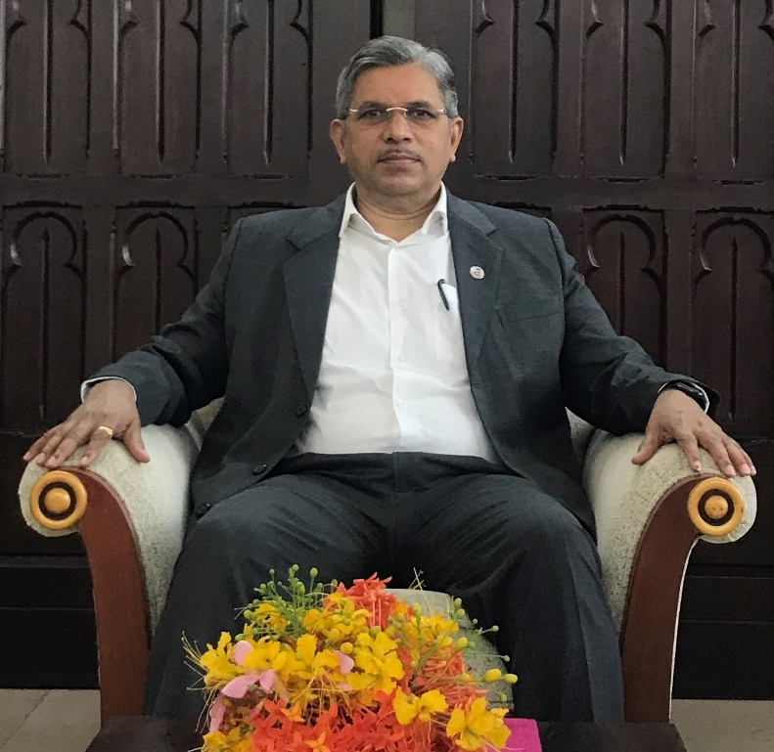
Prof. Suhas Pednekar
Vice Chancellor
University of Mumbai and Dr. Homi Bhabha State University (HBSU)

We are in the fourth revolution where the human skills are rapidly being replaced by automation through AI. This brings the label “Agile Human” into picture that refers to people with physical dexterity and agility. Manual tasks that cannot be automated require capabilities out of reach by machines. We should now find steps in which we stay one step ahead of AI. People should effectively use AI rather than using it mindlessly and becoming slaves to AI. Famous personalities like Sophia the robot, and Elon Musk make headlines regularly. Since this platform has us gathered here today, there is a lot to get enlightened by.

The four themes of the Conference reflect that the departments of CS and IT are making the conscious effort of keeping up with the pace in technological advancements. There is a plethora of research out there. With platforms like these that provide an opportunity to bring out and present the areas of interest, conferences like CyProbe 2020 are intellectual successes. We hope that the participants will gain insights and promote new ideas in the society. I extend my best wishes to all and wish you a successful conference.

Principal’s Message
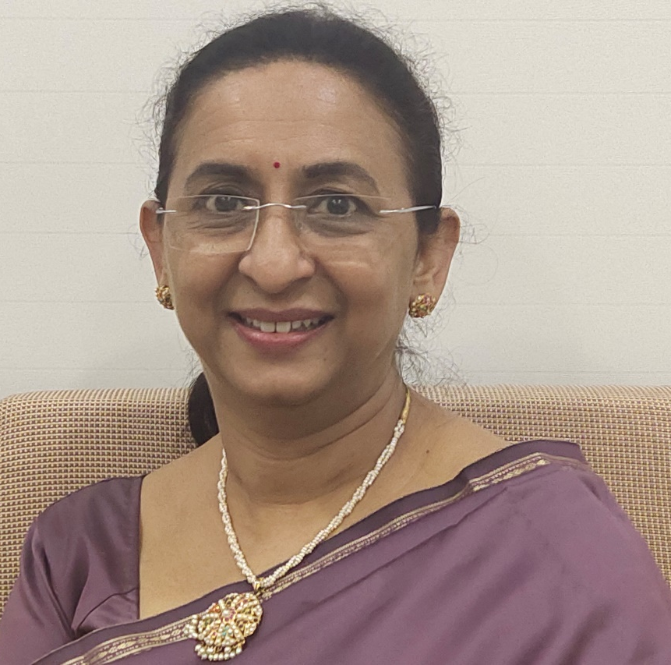

In this golden jubilee year of our college, we have planned and implemented a host of events. Two Memorial lectures – Dr. B.G. Bapat Memorial Lecture Series and Tilak Smruti Vyakhyana were launched. All departments of the college organized various inter-collegiate events to enrich the academic environment. The Golden Dream Run was held to engage with the society. The other events include the Yuva Sahitya Sammelan to popularize cultural values among the youth.
The Departments of Computer Science and Information Technology have made conscious efforts to keep pace with the rapidly changing world. Going beyond the call of duty, the faculty have motivated students to perform to their full potential and enjoy the process of knowledge enhancement. This national conference on Advanced Research in Computer Science and Information Technology - CyProbe is a continuation of our commitment to the cause of holistic education. The conference explores four major areas – Networking and cloud, Application of Information Technology, Artificial Intelligence and Core Computing. In a world of technological advances, these thrust areas will open new avenues for research and newer skill sets for the years to come.
It gives me immense pleasure in wishing well for this National Conference organized by the Departments of Computer Science and Information Technology of our college.

A BRIEF ABOUT ORGANIZING COMMITTEES
Our Patrons
Prof. Suhas Pednekar  Vice Chancellor,  University of Mumbai and Dr. Homi Bhabha State University | Shri Anil B Ganu  President, PTVA
Shri Vinay S Jog  Vice President, PTVA | Shri Dilip M Pethe  Hon. Secretary, PTVA
Shri Hemant K. Bhatawadekar  Hon. Jt. Secretary, PTVA | Shri Bansidhar Sadashiv Dhurandhar Hon. Treasurer, PTVA
Advisory Committee
Dr. K. G. Bhole  Vice Principal (Emeritus),  KET’s V. G. Vaze College | Dr. (Smt.) R. Srivaramangai  Head, University Department of Information Technology,  University of Mumbai
Dr. Rajendra Patil  Coordinator, Department of Information Technology,  S. K. Somaiya College | Dr. Santosh Singh  Coordinator, Department of Information Technology, Thakur College of Science and Commerce
Dr. Tushar Sambare  Coordinator, Department of Information Technology, S. M. Shetty College | Mr. Abhijeet Kale  Coordinator, Department of Information Technology,  B. N. Bandodkar College
Mr. Prakash Patil  Coordinator, Department of Information Technology, K. J. Somaiya College of Science and Commerce | Mrs. Pournima Bhangale  Coordinator, Department of Information Technology,  KET’s V. G. Vaze College
Organizing Committee
Dr. Sonali Pednekar  Principal | Dr. K. G. Rajan  Vice Principal
Dr. Hiren Dand  Co-ordinator  Department of Information Technology | Ms. Reena Shah  Co-ordinator  Department of Computer Science
Mrs. Shilpa Thakur  Co-ordinator  Department of accounting and Finance, Banking and Insurance and Financial Markets | Mrs. Vijayalakshmi Kannan  Co-ordinator  Department of Management Studies and Media Studies
Ms. Jyotika Chheda  Assistant Professor | Ms. Vaishnavi Assar  Assistant Professor
Ms. Priti Pathak  Assistant Professor | Ms. Pooja Patil  Assistant Professor
Mr. Vishal Borude  Assistant Professor | Ms. Shylashree Dev  Assistant Professor
Mr.Jojan Mathai  Assistant Professor | Ms. Bhumika Nakum  Assistant Professor
Mr. Sanketh Iyer  Assistant Professor | Ms. Pratiksha Harwalkar  Assistant Professor

International Journal of Advance and Innovative Research
Volume 7, Issue 1 ( VI ): January - March 2020 Part - 1
Editor- In-Chief Dr. Tazyn Rahman
Members of Editorial Advisory Board
Mr. Nakibur Rahman  Ex. General Manager ( Project )  Bongaigoan Refinery, IOC Ltd, Assam | Dr. Mukesh Saxena  Pro Vice Chancellor,  University of Technology and Management, Shillong
Dr. Alka Agarwal  Director,  Mewar Institute of Management, Ghaziabad | Dr. Archana A. Ghatule  Director,  SKN Sinhgad Business School, Pandharpur
Prof. (Dr.) Sudhansu Ranjan Mohapatra  Dean, Faculty of Law,  Sambalpur University, Sambalpur | Prof. (Dr.) Monoj Kumar Chowdhury  Professor, Department of Business Administration,  Guahati University, Guwahati
Dr. P. Malyadri  Principal,  Government Degree College, Hyderabad | Prof. (Dr.) Baljeet Singh Hothi  Professor,  Gitarattan International Business School, Delhi
Prof.(Dr.) Shareef Hoque  Professor,  North South University, Bangladesh | Prof. (Dr.) Badiuddin Ahmed  Professor & Head, Department of Commerce,  Maulana Azad Nationl Urdu University, Hyderabad
Prof.(Dr.) Michael J. Riordan  Professor,  Sanda University, Jiashan, China | Dr. Anindita Sharma  Dean & Associate Professor,  Jaipuria School of Business, Indirapuram, Ghaziabad
Prof.(Dr.) James Steve  Professor,  Fresno Pacific University, California, USA | Prof. (Dr.) Jose Vargas Hernandez  Research Professor,  University of Guadalajara,Jalisco, México
Prof.(Dr.) Chris Wilson  Professor,  Curtin University, Singapore | Prof. (Dr.) P. Madhu Sudana Rao  Professor,  Mekelle University, Mekelle, Ethiopia
Prof. (Dr.) Amer A. Taqa  Professor, DBS Department,  University of Mosul, Iraq | Prof. (Dr.) Himanshu Pandey  Professor, Department of Mathematics and Statistics  Gorakhpur University, Gorakhpur
Dr. Nurul Fadly Habidin  Faculty of Management and Economics,  Universiti Pendidikan Sultan Idris, Malaysia | Prof. (Dr.) Agbo Johnson Madaki  Faculty, Faculty of Law,  Catholic University of Eastern Africa, Nairobi, Kenya
Dr. Neetu Singh  HOD, Department of Biotechnology,  Mewar Institute, Vasundhara, Ghaziabad | Prof. (Dr.) D. Durga Bhavani  Professor,  CVR College of Engineering, Hyderabad, Telangana
Prof. (Dr.) Shashi Singhal  Professor,  Amity University, Jaipur | Prof. (Dr.) Aradhna Yadav  Professor,  Krupanidhi School of Management, Bengaluru
Prof. (Dr.) Alireza Heidari  Professor, Faculty of Chemistry,  California South University, California, USA | Prof.(Dr.) Robert Allen  Professor  Carnegie Mellon University, Australia
Prof. (Dr.) A. Mahadevan  Professor  S. G. School of Business Management, Salem | Prof. (Dr.) S. Nallusamy  Professor & Dean,  Dr. M.G.R. Educational & Research Institute,Chennai
Prof. (Dr.) Hemant Sharma  Professor,  Amity University, Haryana | Prof. (Dr.) Ravi Kumar Bommisetti  Professor,  Amrita Sai Institute of Science & Technology, Paritala
Dr. C. Shalini Kumar  Principal,  Vidhya Sagar Women’s College, Chengalpet | Dr. Syed Mehartaj Begum  Professor,  Hamdard University, New Delhi
Prof. (Dr.) Badar Alam Iqbal  Adjunct Professor,  Monarch University, Switzerland | Dr. Darshana Narayanan  Head of Research,  Pymetrics, New York, USA
Prof.(Dr.) D. Madan Mohan  Professor,  Indur PG College of MBA, Bodhan, Nizamabad | Dr. Rosemary Ekechukwu  Associate Dean,  University of Port Harcourt, Nigeria
Dr. Sandeep Kumar Sahratia  Professor  Sreyas Institute of Engineering & Technology | Dr. P.V. Praveen Sundar  Director,  Shanmuga Industries Arts and Science College
Dr. S. Balamurugan  Director - Research & Development,  Mindnotix Technologies, Coimbatore | Dr. Manoj P. K.  Associate Professor,  Cochin University of Science and Technology
Dr. Dhananjay Prabhakar Awasarikar  Associate Professor,  Suryadutta Institute, Pune | Dr. Indu Santosh  Associate Professor,  Dr. C. V.Raman University, Chhattisgath
Dr. Mohammad Younis  Associate Professor,  King Abdullah University, Saudi Arabia | Dr. Pranjal Sharma  Associate Professor, Department of Management  Mile Stone Institute of Higher Management, Ghaziabad
Dr. Kavita Gidwani  Associate Professor,  Chanakya Technical Campus, Jaipur | Dr. Lalata K Pani  Reader,  Bhadrak Autonomous College, Bhadrak, Odisha
Dr. Vijit Chaturvedi  Associate Professor,  Amity University, Noida | Dr. Pradeepta Kishore Sahoo  Associate Professor,  B.S.A, Institute of Law, Faridabad
Dr. Marwan Mustafa Shammot  Associate Professor,  King Saud University, Saudi Arabia | Dr. R. Navaneeth Krishnan  Associate Professor,  Bharathiyan College of Engg & Tech, Puducherry
Dr. Mahendra Daiya  Associate Professor,  JIET Group of Institutions, Jodhpur | Dr. G. Valarmathi  Associate Professor,  Vidhya Sagar Women's College, Chengalpet
Dr. Parbin Sultana  Associate Professor,  University of Science & Technology Meghalaya | Dr. M. I. Qadir  Assistant Professor,  Bahauddin Zakariya University, Pakistan
Dr. Kalpesh T. Patel  Principal (In-charge)  Shree G. N. Patel Commerce College, Nanikadi | Dr. Brijesh H. Joshi  Principal (In-charge)  B. L. Parikh College of BBA, Palanpur
Dr. Juhab Hussain  Assistant Professor,  King Abdulaziz University, Saudi Arabia | Dr. Namita Dixit  Associate Professor,  ITS Institute of Management, Ghaziabad
Dr. V. Tulasi Das  Assistant Professor,  Acharya Nagarjuna University, Guntur, A.P. | Dr. Nidhi Agrawal  Assistant Professor,  Institute of Technology & Science, Ghaziabad
Dr. Urmila Yadav  Assistant Professor,  Sharda University, Greater Noida | Dr. Ashutosh Pandey  Assistant Professor,  Lovely Professional University, Punjab
Dr. M. Kanagarathinam  Head, Department of Commerce  Nehru Arts and Science College, Coimbatore | Dr. Subha Ganguly  Scientist (Food Microbiology)  West Bengal University of A. & F Sciences, Kolkata
Dr. V. Ananthaswamy  Assistant Professor  The Madura College (Autonomous), Madurai | Dr. R. Suresh  Assistant Professor, Department of Management  Mahatma Gandhi University
Dr. S. R. Boselin Prabhu  Assistant Professor,  SVS College of Engineering, Coimbatore | Dr. V. Subba Reddy  Assistant Professor,  RGM Group of Institutions, Kadapa
Dr. A. Anbu  Assistant Professor,  Achariya College of Education, Puducherry | Dr. R. Jayanthi  Assistant Professor,  Vidhya Sagar Women's College, Chengalpattu
Dr. C. Sankar  Assistant Professor,  VLB Janakiammal College of Arts and Science | Dr. Manisha Gupta  Assistant Professor,  Jagannath International Management School

Copyright @ 2020 Indian Academicians and Researchers Association, Guwahati
All rights reserved.

No part of this publication may be reproduced or transmitted in any form or by any means, or stored in any retrieval system of any nature without prior written permission. Application for permission for other use of copyright material including permission to reproduce extracts in other published works shall be made to the publishers. Full acknowledgment of author, publishers and source must be given.

The views expressed in the articles are those of the contributors and not necessarily of the Editorial Board or the IARA. Although every care has been taken to avoid errors or omissions, this publication is being published on the condition and understanding that information given in this journal is merely for reference and must not be taken as having authority of or binding in any way on the authors, editors and publishers, who do not owe any responsibility for any damage or loss to any person, for the result of any action taken on the basis of this work. All disputes are subject to Guwahati jurisdiction only.

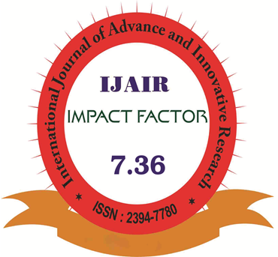

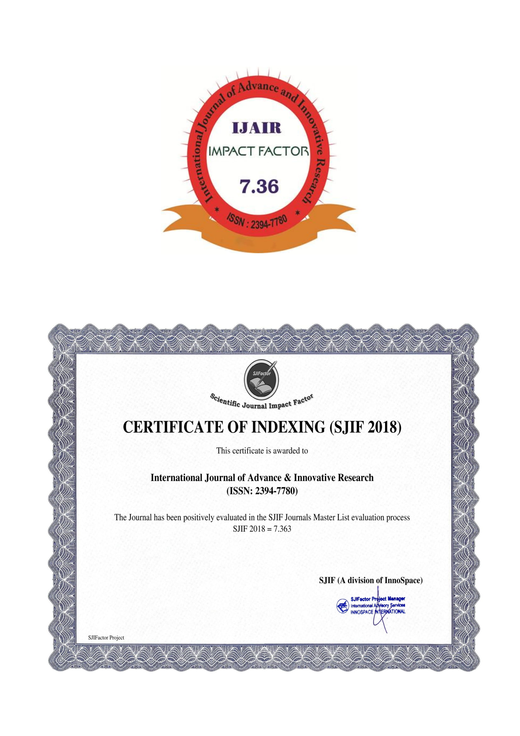

International Journal of Advance and Innovative Research
Volume 7, Issue 1 ( VI ) : January – March 2020 Part - 1
CONTENTS
Research Papers
A review paper on “IOT” & It’s Smart Applications  Sachin S. Bhosale, Ashwini G. Salunkhe and Umera Dalvi | 1 – 5
A Review Paper on Big Data and Hadoop  Vinayak Pujari, Dr. Yogesh K. Sharma and Rohan Rane | 6 – 9
A SOFT COMPUTING TECHNIQUE AND THEIR APPLICATIONS  Sachin S. Bhosale, Ashwini G. Salunkhe and Riddhi Pawar | 14 – 19
A STUDY ON DIGITAL MARKETING AND ITS IMPACT  Vijaya S. Bhosale, Dr. Deepak P. Raverkar and Shamsina Mahaldar | 20 – 23
A Survey on Human Robot Interaction  Sachin S. Bhosale, Ashwini G. Salunkhe and Krantisurya Kadam | 24 – 26
Artificial Intelligence Applications in Medicine  Tejshree Dalvi | 27 – 31
An Analysis cum study on impact of e-commerce on india’s commerce  Vijaya S. Bhosale, Dr. Deepak P. Raverkar and Deepak Sable | 32 – 34
Artificial Intelligence and its Application in Different Areas  Sachin S. Bhosale, Ashwini G. Salunkhe and Shailesh S. Sutar | 35 – 39
Block-chain: Principles applications and future trends  Sooraj Shravan Prajapati | 40 – 43
Business Intelligence for PMS Application  Sachin S. Bhosale, Dr. Yogesh K. Sharma and Pritam Kamle | 44 – 49
Chatbot Application Using Artificial Intelligence  Sachin S. Bhosale, Dr. R. B. Patil and Hasham Khupe | 50 – 52
Cloud Computing: Types, Architecture and Applications  Sachin S. Bhosale, Ashwini G. Salunkhe and Shailesh Sawant | 53 – 56
Cyber Crime: A Change In The Whole Thing  Vinayak Pujari, Dr. R. B. Patil and Omkar Burate | 57 – 61
Cyber Crime & Cyber Law’s in India  Vinayak Pujari, Dr. R. B. Patil and Rohit Dalvi | 62 – 66
E-learning: A Success Model  Vinayak Pujari, Dr. Yogesh K. Sharma and Aashta Memon | 67 – 69
E-Learning using the Chalkboard system in Light of the Quality of Education and Cyber security  Sachin S. Bhosale, Dr. R. B. Patil and Guruprasad R. Lingayat | 70 – 75
Future of E-Commerce in India Challenges & Opportunities  Vijaya S. Bhosale, Dr. Deepak P. Raverkar and Deepak Sable | 76 – 78
IMPORTANCE OF DIGITAL MARKETING IN THE NEW AGE  Vijaya S. Bhosale, Dr. Deepak P. Raverkar and Tejashri Tamondkar | 79 – 82
Indian Rural Market: Opportunities and Challenges  Vijaya S. Bhosale, Dr. Deepak P. Raverkar and Harshada Khaire | 83 – 85
INFLUENCE OF DIGITAL MARKETING ON INDIAN RURAL MARKETING  Vijaya S. Bhosale and Dr. Deepak P. Raverkar | 86 – 90
PRACTICE & BARRIERS OF LEARNING WITH ICT FROM TEACHERS’ PERCEPTIONS  Vinayak Pujari, Dr. Yogesh K. Sharma and Manali Palkar | 91 – 95
RESEARCH PAPER ON ODD PRICING SYSTEM  Vijaya S. Bhosale, Dr. Deepak P. Raverkar and Fayeem Khadas | 96 – 102
Research Paper on Seven P’s of Services Promoting and Victory Promoting Methods at Reliance Jio, Khed  Vijaya S. Bhosale, Dr. Deepak P. Raverkar and Nyamatulla H. Mullaji | 103 – 107
Role and Applications of ICT in Development of Rural Areas  Vinayak Pujari, Dr. Yogesh K. Sharma and Aishwarya Kapadi | 108 – 112
Role of Business Intelligence in Digital Marketing  Sachin S. Bhosale, Dr. Yogesh K. Sharma and Farish Kurupkar | 113 – 116
Role of ICT in Higher Education  Vinayak Pujari, Dr. Yogesh K. Sharma and Mahesh Jathar | 117 – 119
Study of Scope in Soft Computing  Sachin S. Bhosale, Dr. R. B. Patil and Sanket Ambare | 120 – 122
The Review of Cloud Computing System  Sachin S. Bhosale, Ashwini G. Salunkhe and Poonam M. Mane | 123 – 127
A Recommender System for Learning Resources Suggestion Based on Learner Characteristics  Pranay Das and Dr. Rajendra B. Patil | 128 – 137
FUTURE OF AI IN EDUCATION  Sumitha Gnanamalar and Hiren Dand | 138 – 140
Smart Parking System using IOT  Ashwinkumar Jaiswar and Pournima Bhangale | 141 – 143
Application of Blockchain in Advanced Study Centre  Durgesh Rajdev Vishwakarma and Dr. Hiren Dand | 144 – 147
Chatbot Application Using Artificial Intelligence  Sachin S. Bhosale, Dr. R. B. Patil and Hasham Khupe | 148 – 150
CLOUD SECURITY: DISTORTION CONTROL AND PRECAUTION TECHNIQUE  Yadnesh Sachin Shimpi and Prakash Patil | 151 – 155
Studying Dark Web a boon or an imprecation  Rishabh Rajendra Ghodke and Pournima Bhangale | 156 – 161
De-Duplication in Cloud Storage: A Review  Rohit Ganpat Kalambe and Kalpesh Anil Dalvi | 162 – 166
E-Banking Security & Encounters  Nishant Ramesh Sinha and Prakash Patil | 167 – 171
A Literature Survey on Face Recognition Systems using Convolutional Neural Networks  Abhay Shah | 178 – 176
Research on Political Promises  Shiv Sagar Prajapati and Prakash Patil | 177 - 186

